GURU NANAK DEV UNIVERSITY, AMRITSAR

DEPARTMENT OF ELECTRONICS TECHNOLOGY

PORTABLE POLLUTION DETECTOR

SUBMITTED BY:
NAME – RAGHAV SHARMA NAME – SATISH KUMAR
ROLL NO – 17042100306 ROLL NO- 18042100367
EMAIL- raghavsharma998845@gmail.com EMAIL- satishkumar75890@gmail.com

Abstract
This is the prototype of the PORTABLE POLLUTION DETECTOR which is mainly used in detecting harmful pollutants such as LPG, CO2, CO, etc. basically we have used gas sensors (MQ2, MQ7, MQ135) in this prototype which will give the accurate value of the pollutants released by the vehicle. The threshold values of the sensors are set on the basis of Indian government norms released by the Indian government
Introduction
A portable pollution detector is a compact and handheld device designed to measure the concentration of various pollutants released by vehicles. The device can be operated by anyone, from individuals concerned about their personal exposure to vehicle pollution to environmental scientists conducting field studies. The user can carry the potable pollution detector with them as they move around the different environments. This device can be beneficial to many of them as now they can check if their vehicle is in optimal condition or not which can be an easy task as it won’t take much time and is also easy to use
Objective
The objective of this project is to monitor the concentration of various gases such as smoke (simulated as SO2), carbon monoxide (CO), and carbon dioxide (CO2) using gas sensors and an Arduino microcontroller. The readings from the sensors are displayed on a 16x2 LCD screen using the I2C communication protocol.
Technology stack
The Technology stack used in this prototype are:
1. Arduino Uno
2. MQ2 Gas Sensor (Smoke detection)
3. MQ7 Gas Sensor (CO detection)
4. MQ135 Gas Sensor (CO2 detection)
5. 16x2 LCD Display with I2C Interface
6. Breadboard
7. Jumper Wires
1: Arduino UNO R3
Arduino Uno R3 is one kind of ATmega328P-based microcontroller board. It includes the whole thing required to hold up the microcontroller; just attach it to a PC with the help of a USB cable, and give the supply using an AC-DC adapter or a battery to get started. The term Uno means “one” in the language of “Italian” and was selected for marking the release of Arduino’s IDE 1.0 software. The R3 Arduino Uno is the 3rd as well as most recent modification of the Arduino Uno. Arduino board and IDE software are the reference versions of Arduino and are currently progressing to new releases. The Uno-board is the primary in a sequence of USB-Arduino boards, & the reference model designed for the Arduino platform.

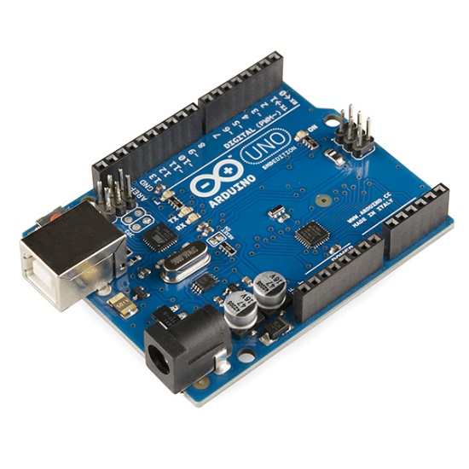
Arduino UNO R3 specification
The Arduino Uno R3 board includes the following specifications.
• It is an ATmega328P based Microcontroller
• The Operating Voltage of the Arduino is 5V
• The recommended input voltage ranges from 7V to12 V

2: MQ 02
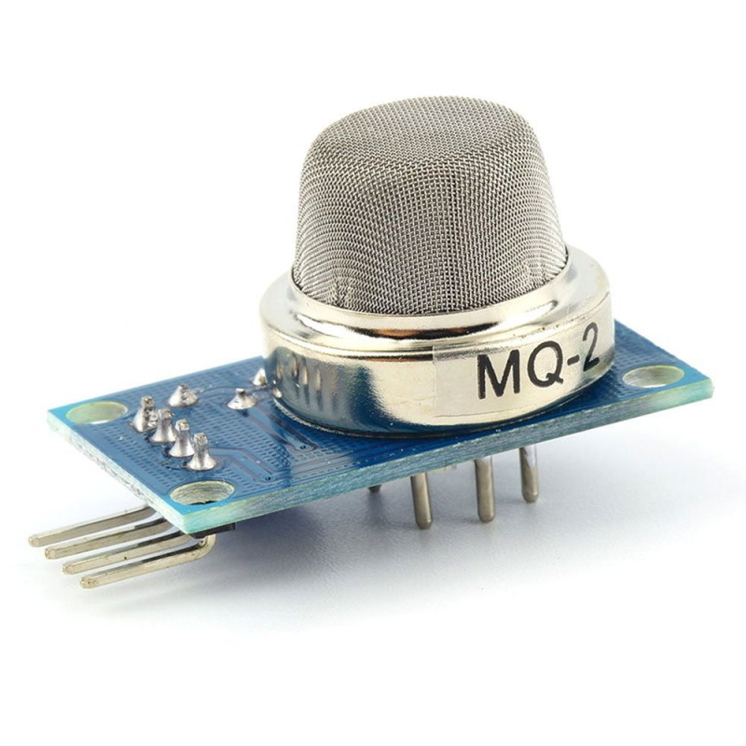
The MQ-2 gas sensor is a module that is commonly used to detect different types of gases, such as smoke, methane, propane, butane, and other combustible gases. The sensor works by measuring changes in resistance as the gas concentration in the air changes.
The MQ-2 gas sensor module typically includes a small heating element, a gas-sensitive resistor, and a circuit board that amplifies the sensor's output signal. The sensor is usually powered by a 5V DC power source and outputs an analog signal that can be read by a microcontroller or other electronics.
The MQ-2 gas sensor module can be used in various applications, such as fire detection systems, gas leakage detection systems, and air quality monitoring systems. However, it is important to note that the MQ-2 sensor module has limitations and may not be suitable for all types of gas detection applications. It is recommended to consult the datasheet and use the sensor module in accordance with its specifications and recommended usage.

3: MQ 7
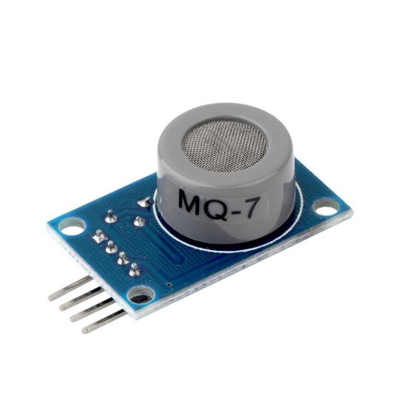
The MQ-7 gas sensor is a module that is commonly used to detect carbon monoxide (CO) gas. It works on the principle of measuring the resistance changes in a tin dioxide (SnO2) sensitive layer, which reacts with carbon monoxide gas. The change in resistance is then converted into an output voltage signal that can be measured by a microcontroller or other electronics.
The MQ-7 gas sensor module typically includes a heating element, a gas-sensitive resistor, and a circuit board that amplifies the output signal. The sensor is usually powered by a 5V DC power source and outputs an analog signal that can be read by a microcontroller or other electronics.
The MQ-7 gas sensor module is commonly used in applications such as gas leakage detectors, CO alarms, and air quality monitoring systems. However, it is important to note that the MQ-7 sensor module has limitations and may not be suitable for all types of gas detection applications. It is recommended to consult the datasheet and use the sensor module in accordance with its specifications and recommended usage.

4: MQ 135
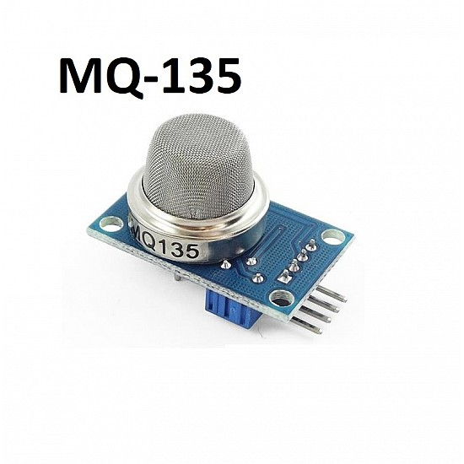
The MQ-135 gas sensor is a module that is commonly used to detect different types of air pollutants, such as benzene, alcohol, smoke, nitrogen dioxide (NO2), and ammonia (NH3). The sensor works by measuring the changes in resistance in a tin dioxide (SnO2) sensitive layer, which reacts with the target gas.
The MQ-135 gas sensor module typically includes a heating element, a gas-sensitive resistor, and a circuit board that amplifies the output signal. The sensor is usually powered by a 5V DC power source and outputs an analog signal that can be read by a microcontroller or other electronics.
The MQ-135 gas sensor module can be used in various applications, such as air quality monitoring systems, indoor air quality monitoring systems, and smart home automation systems. However, it is important to note that the MQ-135 sensor module has limitations and may not be suitable for all types of gas detection applications. It is recommended to consult the datasheet and use the sensor module in accordance with its specifications and recommended usage.

LCD 16*2(1602)
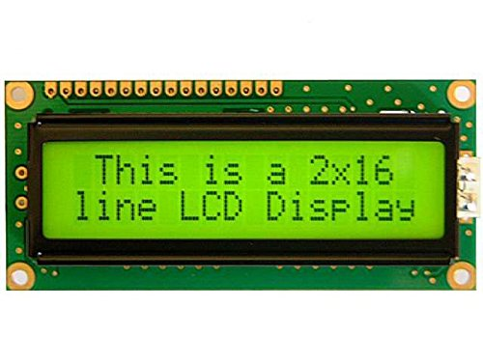
In your air quality monitoring system, the LCD (Liquid Crystal Display) plays a crucial role as the primary user interface. Here's a detailed look at its function and use in the project:

### Function of the LCD:
1. *Data Display*: The primary function of the LCD in this project is to display real-time data. It shows the concentrations of various gases detected by the sensors, such as smoke (simulated as SO2), carbon monoxide (CO), and carbon dioxide (CO2). Each gas concentration is presented in a readable format, allowing immediate interpretation of the air quality.

2. *Feedback Interface*: Beyond displaying raw data, the LCD can also provide feedback based on predefined thresholds. For example, if the concentration of any gas exceeds a certain limit, the LCD can display warning messages like "High CO2" or "Unsafe Air Quality."

3. *System Status Indicators*: The LCD can show system statuses such as "System Ready," "Calibrating," or "Error" to give users real-time updates on the system's operational state.

### Use of the LCD in the Project:
1. *Real-Time Monitoring*: The LCD allows users to monitor air quality in real-time without needing any additional devices or interfaces. This instant access to data is vital for assessing environmental conditions quickly and accurately.

2. *User Interaction*: By displaying data continuously, the LCD facilitates user interaction with the monitoring system. Users can see the effectiveness of air purifiers or ventilation changes based on immediate feedback from the LCD.

3. *Educational Tool*: In educational settings, the LCD helps demonstrate how various factors affect air quality. It can be used in classrooms to teach students about environmental science and the importance of air quality.

4. *Portable Monitoring*: In portable versions of the air quality monitor, the LCD is essential for delivering on-the-go readings. It allows the device to be used in various locations, from indoor rooms to outdoor environments, providing versatility in monitoring air quality.

5. *Cost-Effectiveness*: Using an LCD is a cost-effective way to provide a visual output device on the system. It avoids the need for more complex and expensive display technologies or external computer software, reducing the overall system cost.

### Integration with the System:
The LCD in this project is typically connected via an I2C interface, which minimizes the wiring complexity and conserves microcontroller pins for other uses. This setup enhances the modular design of the project, allowing for easy updates and maintenance.

Overall, the LCD enhances the functionality and user-friendliness of the air quality monitoring system, making it accessible and practical for a wide range of users and applications.

Circuit diagram
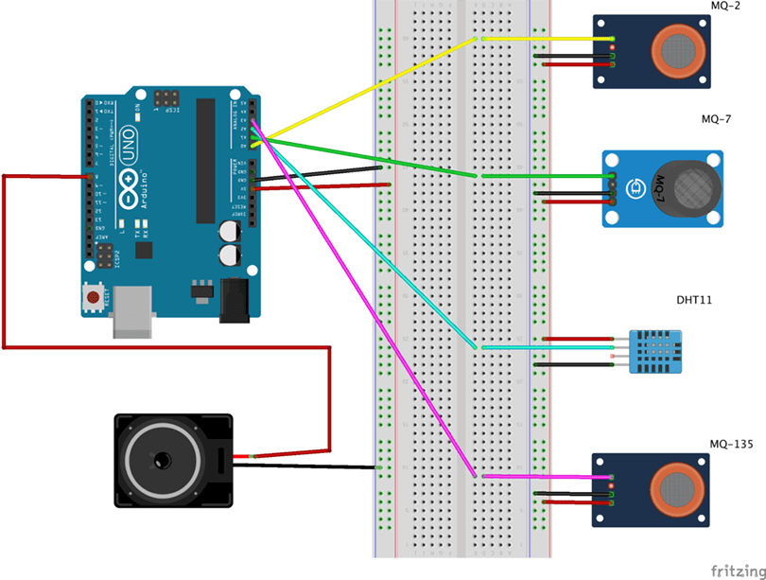
CODE
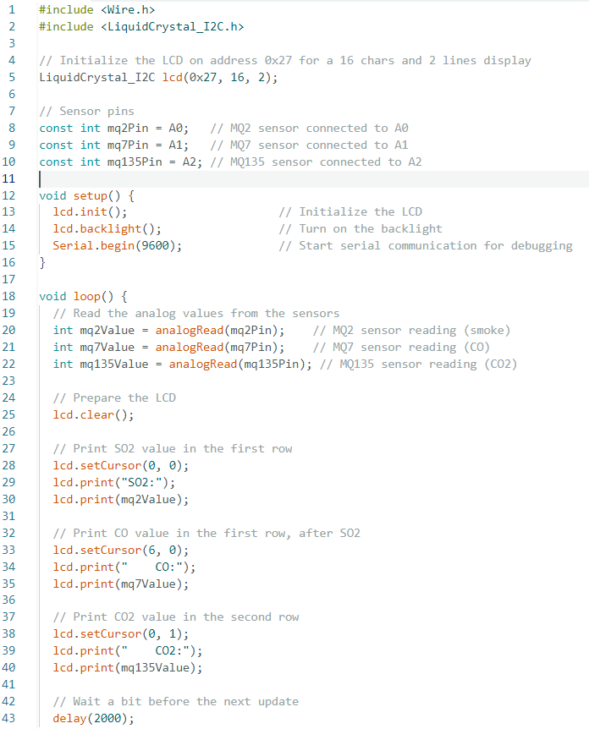
METHODOLOGY
Methodology:
The system utilizes three gas sensors (MQ2, MQ7, and MQ135) connected to an Arduino Uno. The MQ2 sensor is used for detecting smoke, the MQ7 sensor for carbon monoxide, and the MQ135 for carbon dioxide levels in the air. Each sensor's analog output is connected to the Arduino's analog pins. The Arduino processes these readings and displays the values on the LCD. The I2C protocol facilitates communication between the Arduino and the LCD, reducing the complexity of the wiring.

The code for the Arduino is written in C++. It initializes the sensors and LCD, reads the sensor outputs, processes the data, and displays the readings on the LCD. The display shows the concentration of gases detected by each sensor, cycling through the readings every 2 seconds to provide a real-time update of air quality.

Results and Discussion:
The system provides real-time monitoring of air quality by displaying the concentration levels of various gases. This can be used in homes, offices, or industrial areas to continuously monitor air quality. The use of an LCD allows for an immediate and clear display of data, and the portability of the system means it can be installed in various locations.
Conclusion
Portable pollution checkers are valuable tools for monitoring air quality and identifying pollutants in a given environment. They are typically small and lightweight, making them easy to transport and use in a variety of settings, including indoors and outdoors. Portable pollution checkers can detect a wide range of pollutants, including particulate matter, volatile organic compounds, and gases such as carbon monoxide and nitrogen dioxide.
The accuracy of portable pollution checkers can vary, depending on factors such as the quality of the sensors and the calibration of the device. However, many models are highly accurate and can provide real-time data on air quality, allowing individuals and organizations to make informed decisions about their exposure to pollutants.
Overall, portable pollution checkers are valuable tools for promoting public health and raising awareness about the importance of air quality. They can be used by individuals, communities, and governments to monitor pollution levels and take action to reduce emissions and improve air quality.
So this was our project of a prototype of Portable Pollution checker
Thank you…

